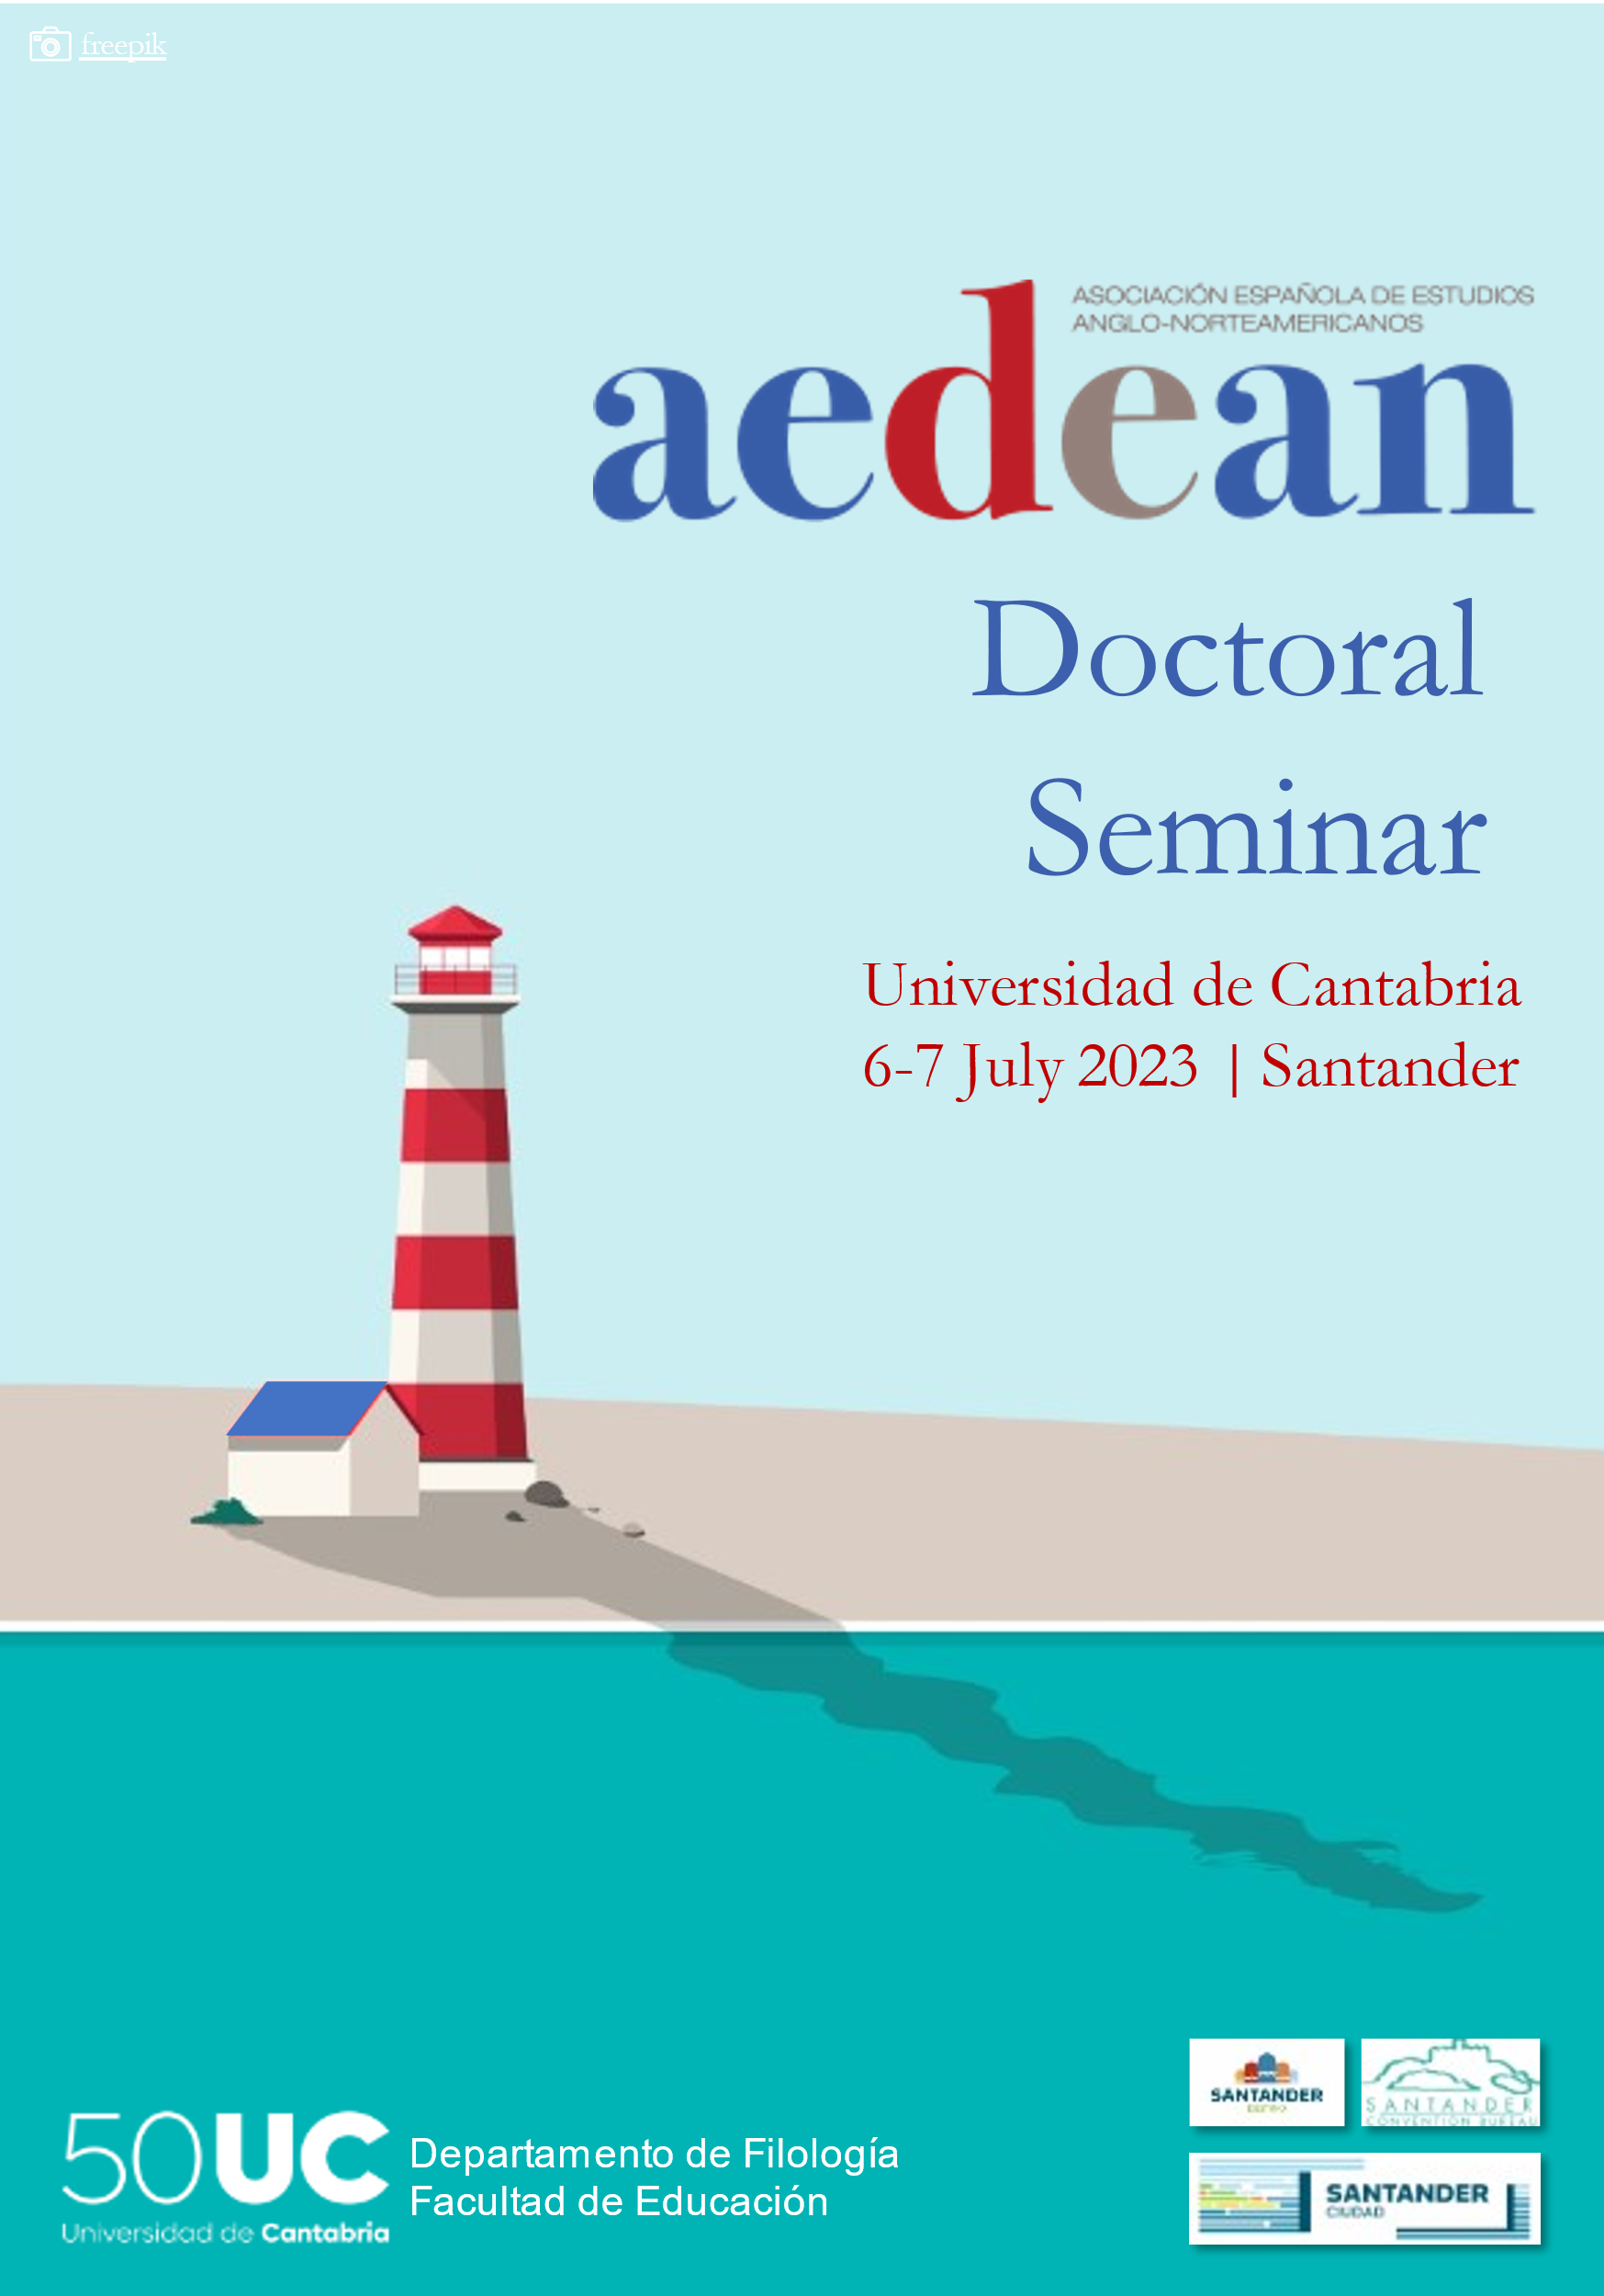

IV AEDEAN DOCTORAL SEMINAR
University of Cantabria ‖ 6-7 July 2023
Philology Building – Avda. Los Castros 52, 39005 Santander

FINAL PROGRAMME

July 6, 2023
9:00-9:45 | Registration (Philology Building-First floor)
9:45-10:00 | Welcome and Opening (Aula 7)
10:00-11:00 | Plenary Session 1 (Aula 7)  José Antonio Sánchez Fajardo (Universitat d’Alacant): “Nail that Conference Paper! Dos and Don’ts to Succeed”
11:00-11:30 | Coffee break
11:30-14:00 | Parallel Sessions
Linguistics (Aula 1)
Coord. María del Pilar García Mayo (UPV/EHU) & Juan Manuel Hernández Campoy (Universidad de Murcia)
- Pedro Humánez-Berral (Universidad de Cantabria): “On Primary Education Students’ Attitudes towards English Pronunciation”
- Stella Ville (Universitat de les Illes Balears): “The Verbotonal Method for English Pronunciation Teaching”
- Timothy William Lawrence (Universidad de Cantabria): “A Meaning-based Analysis Derived from Método de los Relojes Employing Parataxis and Hypotaxis through CEFR Descriptors to Indicate Development of Syntactic Complexity by Spanish and English L1 in L2 Written Texts”
- Beatriz Mediavilla Martínez (Universidad de Burgos): “Integrating Intercultural Communication in English Language Teaching Education: A Proposal”
Literature and Culture (Aula 2)
Coord. Mª Dolores Herrero Granado (Universidad de Zaragoza) & Ana Mª Manzanas Calvo (Universidad de Salamanca)
- Carla Abella Rodríguez (Universidad de Salamanca): “Monitoring Blackness: Inhospitality in African American Literature”
- Paula Serrano Elena (Universidad de Zaragoza): “Motherhood and Mental Health in Post-pandemic North-American Literature: An Analysis of Nightbitch by Rachel Yoder”
- Claudia García Pajín (Universidad de Oviedo): “From ‘Angry Young Men’ to ‘Angry Young Women’: The Evolution of ‘Anger’ in Anglo-American Contemporary Literature”
- Luis Cañadiña Pons (Universidad Complutense de Madrid): “Dehumanization & De-gendering: Understanding Alzheimer’s Disease through its Representation in Contemporary North American Literature
 | Break: 12:45-13:00
- Cecília Almeida Rodrigues (Universidad de Valladolid): “‘At the Wall’: Sir Thomas Wyatt in Spain”
- Guillem Mas Solé (Universitat de Lleida): “Of Time and Existence: A Study of Existentialist Constructions of Old Age in English Renaissance Playtexts”
- María del Mar Coronado (Universidad Pablo de Olavide): “Is Shakespeare’s Love Interpretation Bawdy? Research into the Influence of the Social Context in Translation”
14:00-15:30 | Lunch
15:30-17:30 | Parallel Sessions
Linguistics (Aula 1)
Coord. María del Pilar García Mayo (UPV/EHU) & Juan Manuel Hernández Campoy (Universidad de Murcia)
- María Paula Roverso (Universidad de Cantabria): “Authorial Stance in English Medical Research Article Introduction”
- Ana Eugenia Sancho Ortiz (Universidad de Zaragoza): “The use of Twitter in Science Dissemination: First Steps in the Study of Knowledge Recontextualization”
- Antonio Hermán-Carvajal (Universidad de Granada): “Access to Scientific Information on Mental Health: How Are Emotion-enriched Texts Perceived by English Native Speakers?”
Literature and Culture (Aula 2)
Coord. Mª Dolores Herrero Granado (Universidad de Zaragoza) & Ana Mª Manzanas Calvo (Universidad de Salamanca)
- Rosa Haro Fernández (Universidad de Málaga): “Female Attachment in Contemporary Fiction in English”
- Marta Martín Amor (Universidad de Alcalá): “The Construction of the Female Experience in Contemporary Feminist Irish Drama”
- Olalla López Muñoz (Universidad de Oviedo): “The Passions and Affects of Female Characters in Ian McEwan’s Atonement”
- Sara Tabuyo Santaclara (Universidade de Vigo): “Girlhood as a Methodology: An Innovative Approach to The Handmaid’s Tale Universe”
- Iria Seijas Pérez (Universidade de Vigo): “Queering Girlhood: Lesbian and Bisexual Female Protagonists in Contemporary Irish Young Adult Literature in English”
- Asunción Sánchez Padilla (Universidad Complutense de Madrid): “Ideological Reception of Translated LGBTI+ Theatre in the Post-Franco Era: British and American Plays on the Spanish Stage”
17:30-18:00 | Coffee break
18:00-18:55 | Question and Answer Session (Aula 2)
20:00-21:00 | Welcome cocktail offered by Santander City Council (Palacio de Exposiciones)

July 7, 2023
9:30-10:30 | Plenary Session 2 (Aula 7)  Jorge Diego Sánchez (Universidad de Salamanca): “Research in Action: How to Fill (and Develop) Knowledge Transfer”
10:30-11:00 | Coffee break
11:00-13:30 | Parallel Sessions
Linguistics | Linguistics (Aula 1)  Coord. María del Pilar García Mayo (UPV/EHU) & Juan Manuel Hernández Campoy (Universidad de Murcia)  - Hugo Alvarez Manso (Universidad de Oviedo): “A Corpus-based Study of the Uses of Modal Verbs and their Grammaticalization in the History of English”  - David Hernández Coalla (Universidade de Vigo): “Approaching Non-standard Second Person Pronouns”  - Fahad Alyaqout (Universidade de Vigo): “Predicting Pitch Prominence in Tri-Constituent Compound Nouns: A Speech Perception and Production Analysis”  - Carmen Moreno Romero (Universidad de Granada): “Machine Translation for Non-expert Users within Public Administrations”
Literature and Culture (Aula 2)
Coord. Mª Dolores Herrero Granado (Universidad de Zaragoza) & Ana Mª Manzanas Calvo (Universidad de Salamanca)
- Paula Rustarazo Garzón (Universidad de Málaga): “Maternity, Fertility and Loss in Contemporary Memoir and Fiction”
- María Abizanda Cardona (Universidad de Zaragoza): “Reading the Posthuman at the Crossroads of Mystery and Speculative Fiction”
- Lidón Prades Yerves (Universitat Jaume I): “The Use of Exempla in Middle English Arthurian Literature”
- Ángela Gómez García (Universidad de Cantabria/Universidade de Santiago de Compostela): “Everything about me invites you in”: An Introduction to the Monster and its Creation; Masculinities and Viewer Reception in Dracula, The Vampire Diaries, Fifty Shades of Grey and After”
 | Break: 12:15-12:30
- Inés Hernández Martínez (Universidad de Oviedo): “Welcoming Dissidences through Fiction: What’s Left when Normative Relationships Are Dead?”
- María López González (UNED): “‘Other Indias’: Heterodox Visions and Representations in Indo-Anglian or Anglo-Indian Writing in English”
- Clara Sánchez Trigo (Universidad de Málaga): “Re-orienting Emotions and Affect in Contemporary Literature and Videogames”
13:45-14:00 | Closing and delivery of certificates (Aula 7)

